Foster and Kinship Carers
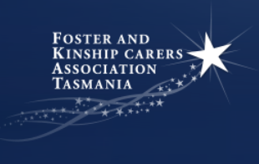
Save the Date
Training Sessions 2018
Session one:  **May 2018**  legal issues & transfer of guardianship |  | Session two:  **August 2018**  Child behaviour coming into care & transition out of care-leaving care plans

In collaboration with FKAT, Children and Youth Services would like to invite all foster and kinship carers to attend the 2018 training sessions. The training sessions will include information on legal issues, transfer of guardianship (May 2018) and Transition out of care and leaving care plans (August 2018)

**Lunch will be provided ~ Childcare will be available**

Session One:
The May session will focus on working with the Legislation, Children, Young persons and Their Families Act (1997) and understanding orders. As well as a session on Transfer of guardianship – the what, why and how.

Session Two:
The August session will focus on children coming into and out of your care. Julian Watchorn will case study ‘what behaviour to expect when a child comes into your care’. There will be a focused session on transferring out of care and leaving care plans.

Who should attend?
Foster and Kinship Carers

Time:
Commence: 9:45 am Finish: 2:45 pm

Dates & Venue**
NORTH WEST:
Session 1: Wed 23 May Session 2: Wed 8 Aug

NORTH:
Session 1: Thur 24 May Session 2: Thur 9 Aug

SOUTH:
Session 1: Thur 31 May Session 2: Mon 6 Aug

**Venues to be confirmed

Catering & Childcare will be available
Tea, coffee and Lunch will be provided

Registration:
Please RSVP no later than a week prior to the event to FKAT via email: ceo@fkat.org.au. Please include:-
- any dietary requirements eg Gluten Free, Vegetarian etc
- *Child care requirements; including number of children requiring care, their names, ages and any special considerations

Further Information:
For any further details on this training event please contact your local FKAT representative or Kim Backhouse on ceo@fkat.org.au

