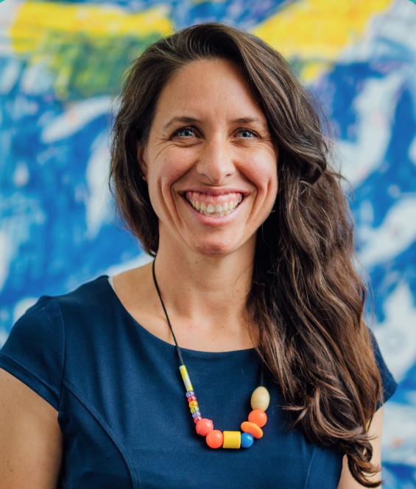
Hi, I'm Leanne and I am Tasmania's Commissioner for Children and Young People.
A little while ago I found out that some children and young people in care no longer have an individual Child Safety Officer - or case worker, as you might know them. Instead, they have a team to talk to at Child Safety if they need support.
I have spoken with some young people in care who told me good things about this change, and some other young people who have told me things that are not so good.
I am now looking into how this change was made and what this means for children and young people in care.
I need your help.
It is important that I hear from more children and young people in care about this change and about how their voices were listened to.
- You don’t need to answer all the questions if you don’t want to.
- You don't have to share your name or any other personal details - I won't know who you are unless you want me to.
- There are no 'right' or 'wrong' answers – I just want to hear what you have to say.
- You can have a support person like your carer or someone you trust to help.

If you find yourself feeling sad, or worried or are thinking about this over the next couple of days, please reach to someone you trust and ask for help. You can also ring Kids Help Line on 1800 55 1800 (it’s a free call from any phone) or go online to www.kidshelpline.com.au

Thinking about case workers
One of the people who can be therefore children in care are child safety officers. We know a lot of kids call them caseworkers so that’s the word we will use in these questions.

Why is it important to have a case worker?

Can you tell us about your case worker?

Can you tell us about your experience(s) with your case worker?

Changes to who your child safety officer is
Some children in care have told us that there has been a change from having individual caseworkers (CSO’s) to having a phone number / email to a team within child safety.

Can you tell me what you know about this change?

Can you give me some details about when and how you were told about this?

How did you feel when you heard about this change?

What about the impacts on you?
Children have told us some good things and bad things about this change.
Other children have told us that they have not noticed much difference.

Can you tell us about what the change has been like for you?

Have there been any good things about this change for you?

Have there been any bad things about this change for you?

Being asked about your ideas
Children in care have the right to have a say in decisions that will impact their lives. This includes any changes to their care – like the recent change for some kids who no longer have an individual case worker.

How should children in care have a say about changes to their care?

Did you have a say about if this change with case workers should happen?

Why is it important for you, and other children in care to have a say about things?

And finally, a bit about you. Please only answer the questions you feel happy to answer.

How old are you? (please circle your answer)

5-8
8-11
12-15
15-18
18+

Are you currently living in care? (please circle your answer).

Yes

No

If you need more space to write your answers, please write it in here

