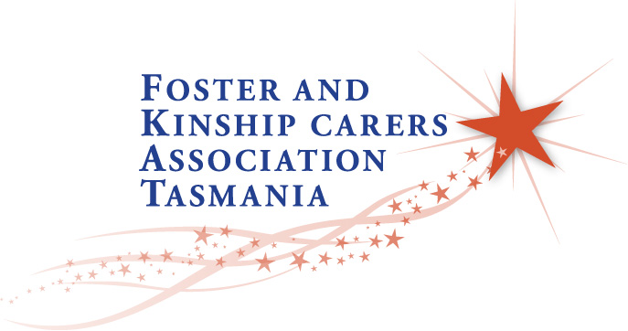
2023 National Foster & Kinship Care Conference
Speakers Expression of Interest
Foster and Kinship Carers Association Tasmania is delighted to host the 2023 National Foster and Kinship Care Conference in Hobart, Tasmania from 21st - 23rd September 2023.
We invite representatives from the child protection sector (both non-government and government), academics, professionals, advocates and representatives of people with a lived experience of the child protection system to express interest in delivering a presentation or facilitating a workshop.
We seek expressions of interests from speakers in the following areas:
- Keynote speakers.
- Plenary presentations, workshops and panel-led discussions.
- Poster presentations i.e. academic, research & community information posters.
This conference will provide a unique opportunity for all child protection stakeholders to learn from, and alongside, Foster and Kinship Carers, in a collaborative environment. Delegates would like to hear from expert local, national and international keynote speakers on major issues facing the Foster and Kinship Care sector; with the primary focus on ensuring our children and young people thrive and reach their full potential.
This conference will be culturally responsive, and progressive in reflecting current caring trends and aim to attract participation from a diverse audience of Carers, professional stakeholders, researchers and young people in the Foster and Kinship Care sector.
It is essential all presentations encompass one or more of the four themes of the Conference:
- Mental Health
- Trauma
- Well-Being
- Culture
All delegates will be provided the opportunity to explore their contemporary thinking on a national platform.
Keynote speakers
The keynote speakers will include an opening keynote and closing keynote speaker. An opening keynote speaker will set the underlying tone of the Conference and summarise the core message or three pillars of the event. The closing keynote speaker will be engaged to end a conference on a high note and leave audiences with a sense of optimism.

Plenary workshops & panel-led presentations
The plenary workshop presentations will be practical, proven and oriented towards skills-development for all stakeholders within the child protection sector. Plenary workshop presentations will promote community cohesion and strengthen practices (programs, strategies, activities, methodologies, tools and resources) relating to one or more of the conference themes. Plenary workshops that promote innovative community cohesion strengthening practices and also train trainers will be considered favourably. Panel-led presentations will be considered as essential elements of this conference.
Poster Presentations
Poster presentations will be displayed throughout the conference at the Wrest Point Casino, ensuring all delegates have a chance to view the material during the conference. Presenters will have the opportunity to discuss their poster informally during one of the refreshment breaks. Posters will be A3 size and displayed in the Convention Centre. The poster will concisely summarise information about the presenters research or program, with the objective to generate discussion throught the conference.
Instructions
Speaker application forms must be submitted to ceo@fcatas.org.au by 30th May, 2023.
Presentation descriptions should not exceed 500 words. It should outline the main content and how it contributes to the four themes of the conference: Mental Health, Culture, Well-Being, and Trauma. Presentation descriptions are also asked to outline the methodology of the research and how the content will address current challenges and solutions, through a national lens.
All presenters are to supply a high quality photo and biography (200 words) for inclusion in the conference e-handbook and website.
Presenters will be notified by email by 20th June 2023.

2023 National Foster & Kinship Care Conference
Speakers Expression of Interest Application

Presenter’s Name:
Organisation (if applicable):
Contact Address:

Contact email:
Phone number:
Preferred presentation type:
☐ Keynote presentation
☐ Plenary presentations or workshops (inc. panel-led discussions)
☐ Poster presentation
Preferred Title of Keynote/Plenary presentation or workshop/Poster presentation:
___________________________________________________________

_____________________________________________________________________________________

Does your presentation cover one or more of the four themes of our conference:
☐ Trauma
☐ Well-Being
☐ Culture
☐ Mental Health

Short Description of Keynote/Plenary presentation or workshop/Poster presentation:

Short profile on Presenter (to be included in conference handbook and website):

Thank you for expressing an interest in presenting at the 2023 National Foster & Kinship Care Conference in Hobart, Tasmania. Please submit the completed form to ceo@fcatas.org.au by 30th May, 2023.

